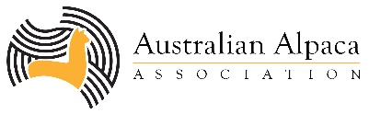
YOUTH COMPETITIONS
Gidgegannup Alpaca Show 2021

DETAIL: Youth events will be held on Sunday 30 May at the Gidgegannup Small Farm Field Day.
Youth events are estimated to run from 9am-1.30pm. Exact start times will be available close to the event.

ENTRIES CLOSE: 4.00 PM Sunday 16 May 2021
FREE ENTRY FOR COMETITION – GATE ENTRY FEE: $5 per person
RETURN completed entry form to AlpacaYouthWA@gmail.com

SECTION: Junior Handlers
CLASS Y1 | Novice 7-12 (<12 months experience with alpaca handling)  Available ages 7 to under 12. 1st Prize $30.00
CLASS Y2 | Novice 12-26 (<12 months experience with alpaca handling)  Available ages 12 to 26. 1st Prize $30.00
CLASS Y3 | Advanced (>12 months experience with alpaca handling)  Available ages 7-26. 1st Prize $30.00
SECTION: Young Judging
CLASS Y4 | Training session with AAA Judge Adrienne Clarke and Young Judging Competition. Available ages 15-26. 1st Prize $50.00

☐ I have read the General Regulations and Conditions contained in the 2021 Gidgegannup Australian Alpaca Association Western Australia Show Schedule and understand that my entry in this show has been accepted subject to those Regulations and Conditions and abide by all decisions in connection with or arising out of the competition.

-----ENTRY FORM-----
Note: Multiple entrants from the same family or school may use the same entry form.
Class No. | Youth Entrant Name | Youth Age

Name of Guardian (if exhibitor is under 18)
Name of Stud or School (if applicable)
Telephone Number
Email Address
Signature |  |  | Date

